CT70A3100 Service Design

Tutorial Assignment - W4 Tutorial 5

Hyechan Shin

100 lines series
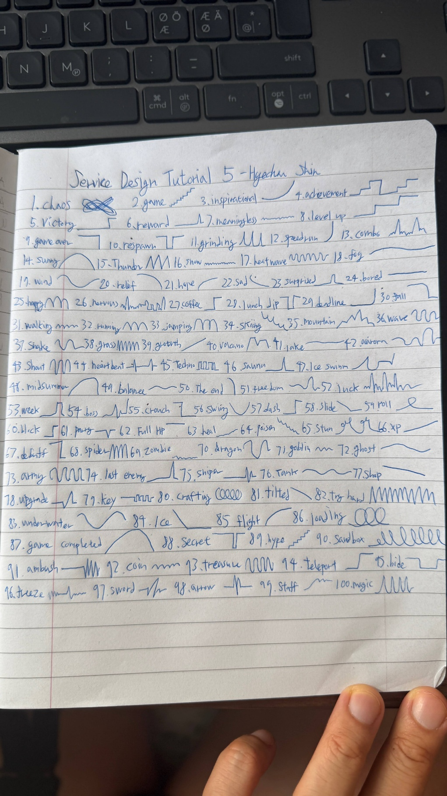

Reflections
When I first started the assignment, I did not understand the assignment, because drawing 100 lines with no purpose seemed confusing to me. However, I came up with the idea of using a game I had played the day before, Dark Souls, so terms such as chaos, achievement, victory, reward, respawn, and game over came quite naturally. The game theme appeared again later in lines such as boss. It was great to have a chance to express myself by drawing. Once I ran out of the idea of the game, I shifted to other themes like weather, emotions, and my daily life activities.

Key take aways
It is normal to get stuck when you run out of ideas, and turning your own thoughts into drawings actually helps with brainstorming. I also repeated the same shapes more often than I expected. Finally, I learned that constraints shape the results.

AI Clarification
ChatGPT was used for grammar check.

